**PROPOSED ARCHITECTURE FOR SMART TRACK AND MONITORING SYSTEM FOR RAILWAYS:**

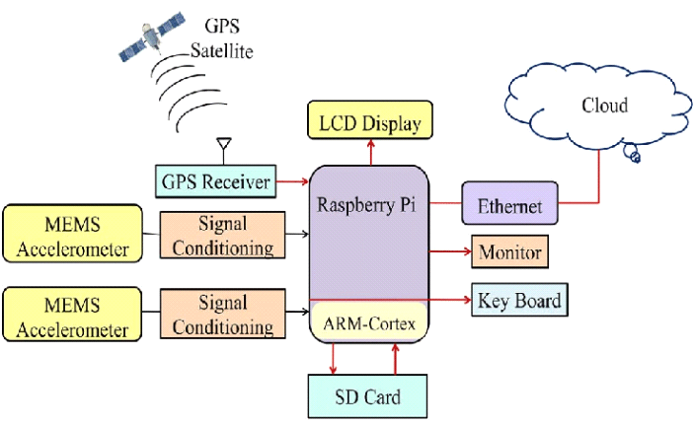

**WORLDWIDE IOT CONNECTED DEVICES:**

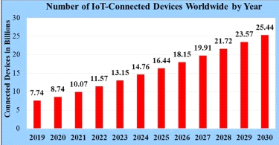

**GPS TRACKING AND TEMPERATURE SENSING:**

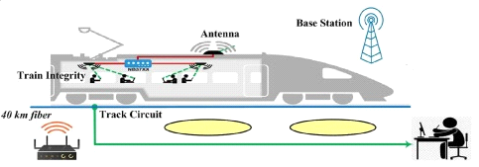

TeamID:PNT2022TMID14986